**UML501 Machine Leaning Project Report**

**Submitted to:** Ms. Anjulo Mehta

Computer ScienceandEngineering Department

TIET, Patiala

November 2023

**Submitted by:**

Lakshay Singhal 102103687

BE Third Year, COE

Group No: 3COE24

Front page..

Index

Introduction

Problem statement

Dataset

Methodology or workflow

Results

Conclusion

Link of your github

**CAR PRICE PREDICTION**

I'll work with the [Kaggle](https://www.kaggle.com/avikasliwal/used-cars-price-prediction) dataset about used cars and their prices. The notebook first includes exploration of the dataset followed by prediction of prices.

There are 12 columns in our original dataset

Name  
Location  
Year  
Killometers Driven  
Fuel Type  
Transmission  
Owner Type  
Millage  
Engine  
Power  
Seats  
New Price  
Price

**MEHTODOLOGY AND WORKFLOW**

**We have used Linear Regression to predict the prize of the different car models.**

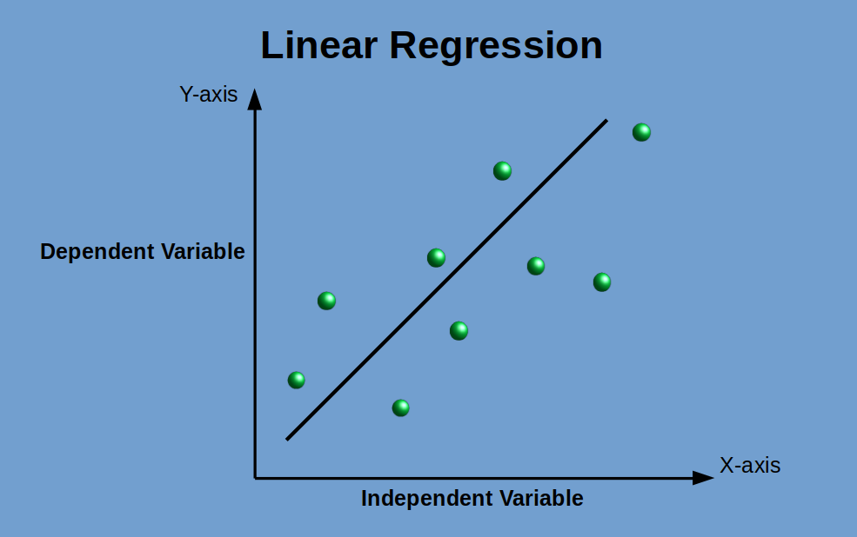

DATA PRE PROCESSING

From The name Column, we have extracted the manufacturer name of the car which will further help us in predicting the prizes.

**FEATURES USED IN PREDICTING**

**We have used 4 features for training and testing.**

**These Include**

* **Manufacturer**
* **Fuel_Type**
* **Transmission**
* **Owner_Type**

**Scaling – Last part of Data Pre Processing**

Scaling is done to normalize the large varying numeric values.

**FINAL OUTPUT**

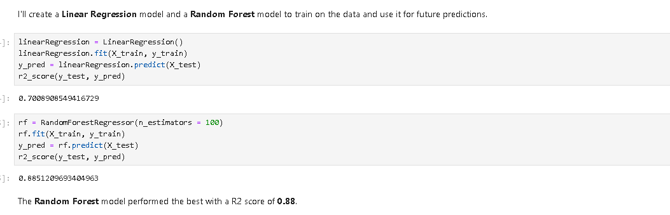

Github Link